1)

INSERT INTO Booking (booking_number, event_number, paid, number_of_tickets, phone, booking_date)

VALUES (1, 2, 'N', 2, '+4365546546', '20161212')

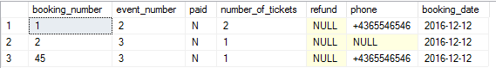

2)

DELETE FROM Booking

WHERE booking_number = 45

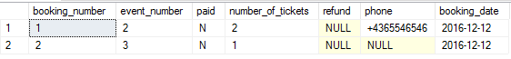

3)

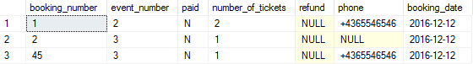

UPDATE Booking

SET number_of_tickets = 1

WHERE booking_number = 45

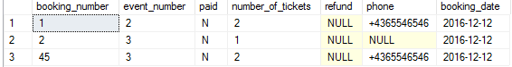

4)

UPDATE Booking

SET paid = 'Y'

WHERE booking_number = 45

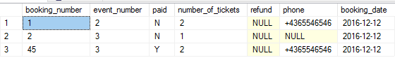

5)

DELETE FROM Booking

WHERE DATEDIFF(DAY, booking_date, GETDATE()) >= 3 AND paid = 'N'

6)

DELETE FROM Booking

WHERE Booking.event_number IN

(SELECT Event.event_number FROM Event WHERE DATEDIFF(DAY, event_date, GETDATE()) > 0) AND paid = 'N'

7)

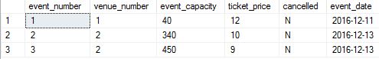

UPDATE Event

SET cancelled = 'Y'

WHERE event_number = 1

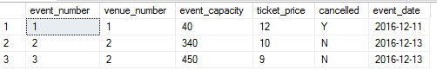

8)

UPDATE Booking

SET refund = 'Y'

WHERE Booking.event_number IN (SELECT Event.event_number FROM Event WHERE cancelled = 'Y')

9)

SELECT * FROM Event

WHERE MONTH(event_date) = 1



10)

SELECT * FROM Performance

JOIN Event ON (Event.event_number = Performance.event_number)

WHERE MONTH(event_date) = MONTH(GETDATE())

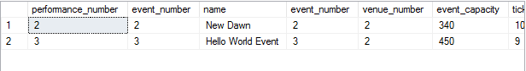

11)

SELECT first_name, surname, phone

FROM Artist

WHERE first_name = 'Snow' AND surname = 'John'



12)

SELECT first_name, surname, catering, event_date

FROM Artist

JOIN Performance ON (Artist.performance_number = Performance.performance_number)

JOIN Event ON (Event.event_number = Performance.event_number)

WHERE first_name = 'Snow' AND surname = 'John'



13)

SELECT SUM(number_of_tickets) AS 'Number of tickets', Performance.name, first_name, surname, Event.event_date

FROM Booking

JOIN Event ON (Event.event_number = Booking.event_number)

JOIN Performance ON (Event.event_number = Performance.event_number)

JOIN Artist ON (Performance.performance_number = Artist.performance_number)

WHERE Performance.name = 'Ego' AND Event.event_date = '20170104'

GROUP BY Performance.name, first_name, surname, Event.event_date



14)

SELECT (event_capacity - SUM(number_of_tickets)) AS 'Tickets', name

FROM Booking

JOIN Event ON (Event.event_number = Booking.event_number)

JOIN Performance ON (Performance.event_number = Event.event_number)

WHERE name = 'Ego' AND event_date = '20170104'

GROUP BY name, event_capacity



15)

SELECT SUM(ticket_price * number_of_tickets) AS 'Ticket price'

FROM Event

JOIN Booking ON (Booking.event_number = Event.event_number)

WHERE paid = 'Y' AND YEAR(event_date) = 2016

